EX NO:13
DATE:
HIERARCHICAL DATA VISUALIZATION USING DRILL-DOWN

AIM: To create a Country–State–City hierarchy using the Sample Superstore dataset in Tableau, perform drill-down operations to explore geographical data at different levels, and demonstrate the advantages of changing colors during drill-down visualization.
Downloaded data –set (Sample Superstore) and perform following actions on the meta data.
•Build up hierarchy of (Country –State -City)
•Drill Down the country hierarchy
•Show the advantage of Changing Colors with the help of drill down concept
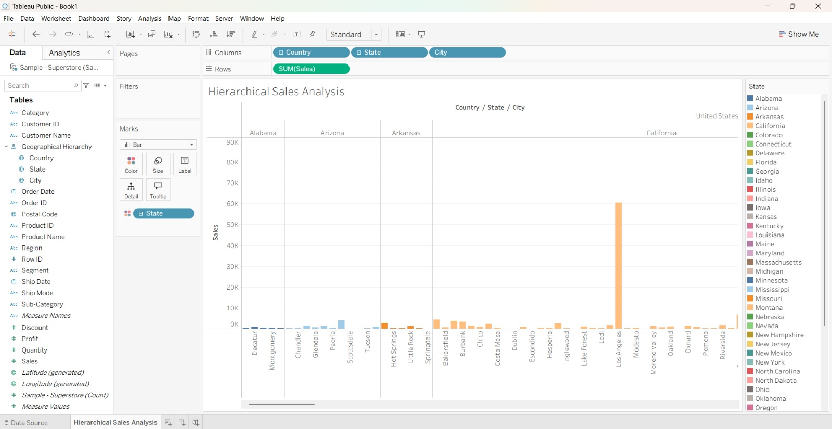

INTERPRETATION: Hierarchical drill-down visualization helps users explore geographical data in detail, identify regional performance differences, and understand patterns at multiple levels. Changing colors improves clarity and makes important variations easier to recognize.

